## 

# Indian Premier League (IPL) Visualization

Aman Patel

Department of Applied Data Science, San Jose State University

DATA 230: Data Visualization

Prof. Andrew H. Bond

December 6, 2023

**ABSTRACT**

India's official T20 cricket league is the Indian Premier League (IPL), which was established in 2008. Teams in the league, which has a round-robin division and knockout format, are based in major Indian towns. The Indian Premier League (IPL) is the most watched cricket competition globally and ranked sixth in terms of average attendance among all sports leagues in 2014. Upon discovering its widespread popularity, I made the decision to pursue data visualizations. In this post, I'll be using the IPL Dataset that I found on Kaggle for statistical data modeling. For this project, I'll be doing some data presentations on various statistics that will be helpful to supporters and fans who wish to assess the IPL and make predictions based on the stats. There will be a considerable increase in understanding if the data is provided as visualizations. I'll make graphs showing who scored the most runs, who took the most wickets, who won the toss, who won by the most runs, who won by the most wickets, who scored the highest total, etc.

Table of Contents

**Indian Premier League (IPL) Visualization**

**1. INTRODUCTION**

* Project Summary

* Purpose

* Intended Audience

**2.** **PROJECT BACKGROUND**

* Project Planning and Scheduling:

* Project Development Approach
* Tableau
* Tableau Features

**3. DATASET**

* IPL dataset

* Preprocessing

* Data Fields

**4. DATA VISUALIZATION**

* Process
* Importing Dataset to Tableau
* Creating different Worksheets
* Worksheet 1
* Worksheet 2
* Worksheet 3
* Worksheet 4
* Worksheet 5
* Worksheet 6
* Worksheet 7
* Worksheet 8
* Worksheet 9
* Worksheet 10
* Worksheet 11
* Worksheet 12

* Dashboards
* Dashboard 1
* Dashboard 2
* Dashboard 3

**5.** **USE CASES**

**6. CONCLUSION**

**7.** **FUTURE GOALS**

**8.** **REFERENCES**

**9. GITHUB**

# INTRODUCTION

## Project Summary

For this project, I created interesting and educational visualizations that offer a comprehensive perspective on IPL data and make it understandable to a variety of users, such as team managers, analysts, and cricket fans. It seeks to make a substantial contribution to the field of cricket analytics by using data visualization and analysis methods to extract insightful knowledge from the IPL's rich and dynamic dataset. I've created several visualizations of the players with the most runs and wickets, the high run percentage venues, the effect of winning tosses, and a lot more. Through in-depth analysis and visualization, I was able to gain a better knowledge of player performances, team dynamics, and the IPL ecosystem as a whole.

## Purpose

Since the Indian Premier League is one of the most fiercely competitive cricket leagues globally, fans, coaches, and pundits all enjoy analyzing and taking notes on their favorite teams. By leveraging IPL data to create visualizations, fans and cricket enthusiasts might be attracted in. The principal aim of this project is to conduct an analysis using various visualization techniques, with the goal of providing coaches and teams with useful information to help them maximize the performance of their teams. Visualizing team performance, dynamics, and strategies can provide valuable insights on player combinations, strategies, and the interplay of various elements that contribute to a team's success. Visualizations that compare and contrast a player's performance over multiple seasons can be helpful to coaches and teams in identifying patterns, trends, and areas that require improvement.

## Intended Audience

1. Professor
2. Fellow Students
3. Cricket Fans .
4. Franchise Teams
5. Players & Coach.

# PROJECT BACKGROUND

## Project Planning and Scheduling

* For this project, Tableau has been utilized to visualize data pertaining to multiple IPL seasons. This project addresses a variety of visualizations, including whether the team's probability of winning or losing depends on the result of the coin toss, which field is more favorable for the batting or bowling as well side, which team has won the most championships and how many times it won in one season, and so on.The main objective of this research is to investigate this using different visualizations so that teams, players, and coaches may emphasize these visuals to maximize team performance.

## Project Development Approach

### Tableau

* Tableau is a prominent data visualization application for corporate intelligence and data analysis. A wonderful tool for business intelligence and data visualization, Tableau allows you to report on and analyze vast volumes of data. It was established in the United States in 2003, and Salesforce acquired Tableau in June 2019. It helps users create a range of dashboards, stories, maps, and graphs to visualize and analyze data to support business decision-making. Tableau's abundance of unique and intriguing features makes it one of the most popular business intelligence (BI) tools available.

### Tableau Features

* Tableau's user interface is easy to understand and navigate, making it suitable for both novice and expert users. Tableau is compatible with a large number of data sources, such as databases, spreadsheets, cloud-based data, and more.
* It has a wide range of visualization choices, such as bar charts, line charts, scatter plots, maps, and more, available with tableau. By fusing several visuals into one display, Tableau users may build interactive dashboards.
* Within visualizations, users may effortlessly filter and highlight particular data points, allowing for a more focused investigation of specific data segments or trends. Thanks to Tableau's robust mapping features, users may display geographical data on interactive, educational maps.
* Tableau can link to live data sources for projects that need real-time data updates, guaranteeing that visualizations show the most recent data. Tableau enables users to share their dashboards and visualizations with others, which promotes cooperation.

# DATASET

## IPL dataset

* IPL Complete Dataset
* Dataset Source : Kaggle
* Dataset size : 51 MB

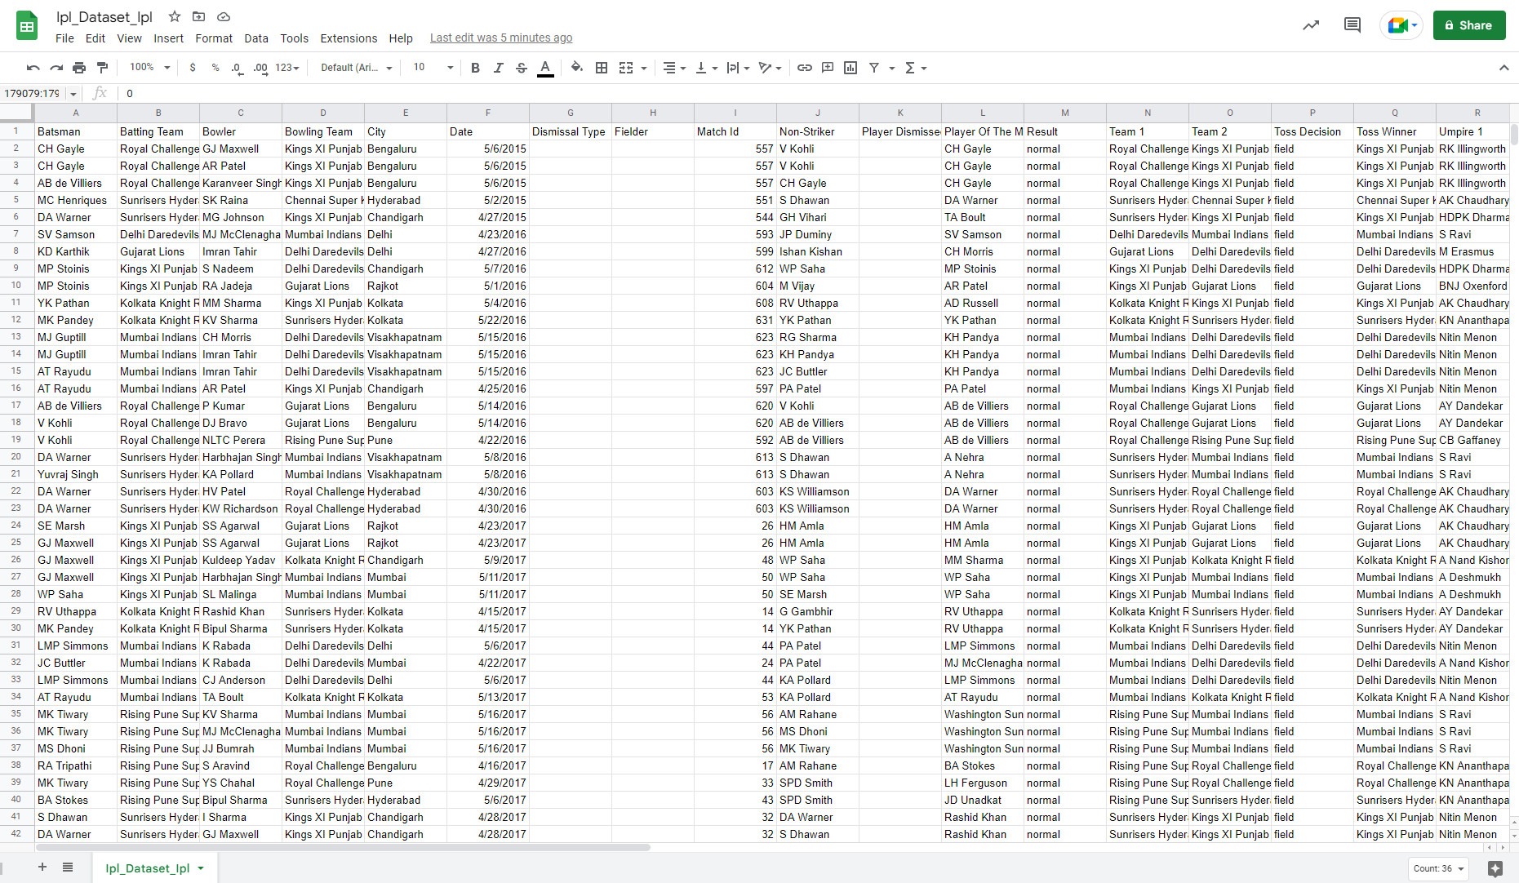

## Preprocessing

* The dataset comprises a total of 4 individual datasets.
* I dropped multiple unwanted columns and also removed all missing values
* As the dataset was already cleaned, so not much preprocessing was required on the data.
* Total number of columns available for visualizations are 39.

## Data Fields

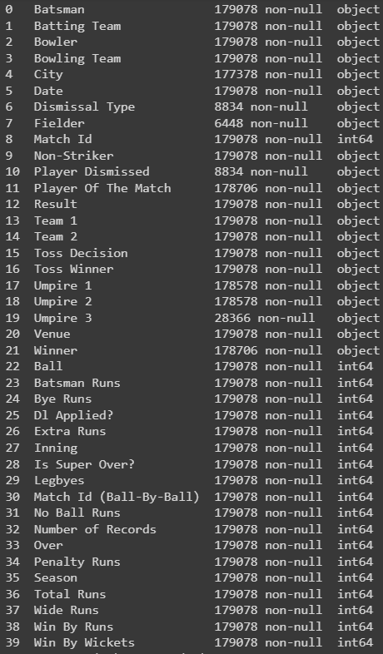

# DATA VISUALIZATION

## Process

### Importing Dataset to Tableau

* First step here is to locate the tableau text file connector.
* In the second step we will go for the CSV file connector.
* In the third step we will locate our CSV from our local computer.
* In the last and fourth step we will configure the CSV text file properties.

### Creating different Worksheets

* I have created a total of 12 worksheets for player and team statistic visualizations over different seasons.
* I have further given a detailed explanation for each and every sheet with proper headings in sheets too.
* The team with the most wins overall, the average win percentage of each team, the team with the most wins in coin flips, the various ways that a toss affects a team's win rate, and many other significant statistics were displayed.

### Worksheet 1:

* It shows the wins for each Franchise in the overall season of IPL, where Mumbai Indian leads with 109 wins, followed by Chennai Super Kings with 100 wins.

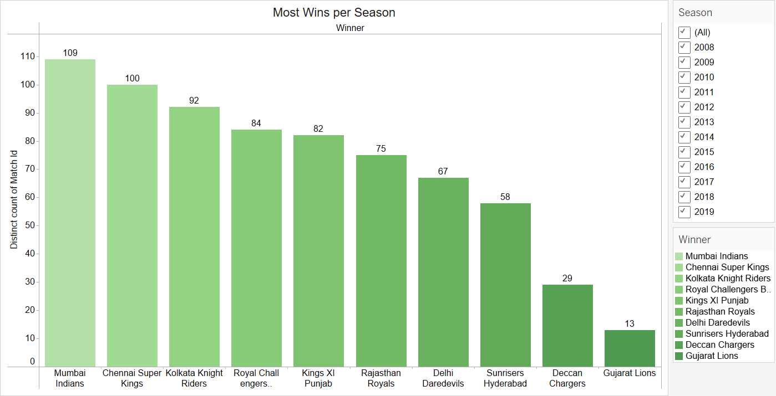

### Worksheet 2:

* It shows the average winning percentage of a particular team on the basis of wickets, in the following seasons as per you search.

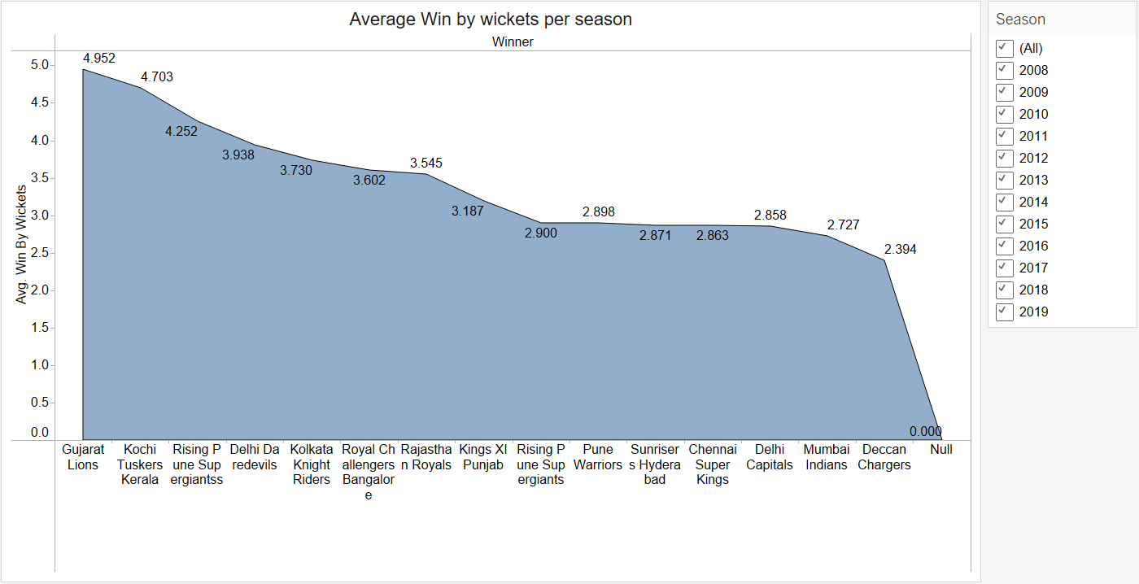

### Worksheet 3:

* This shows the winning percentage of a particular team over the number of matches played in the total season. Here, Mumbai Indians have the highest winning percentage of 14.42% in total.

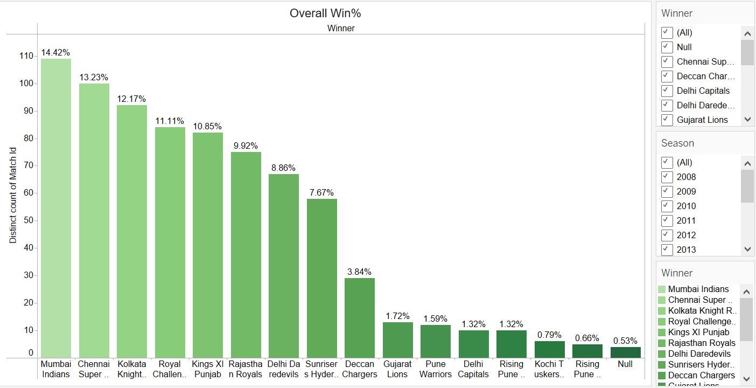

### Worksheet 4:

* It shows the average of wins by runs for a particular team in each seasons, where Chennai Super Kings were seen leading with overall average of 17.57%, followed by Mumbai Indians with 16.97% in total.

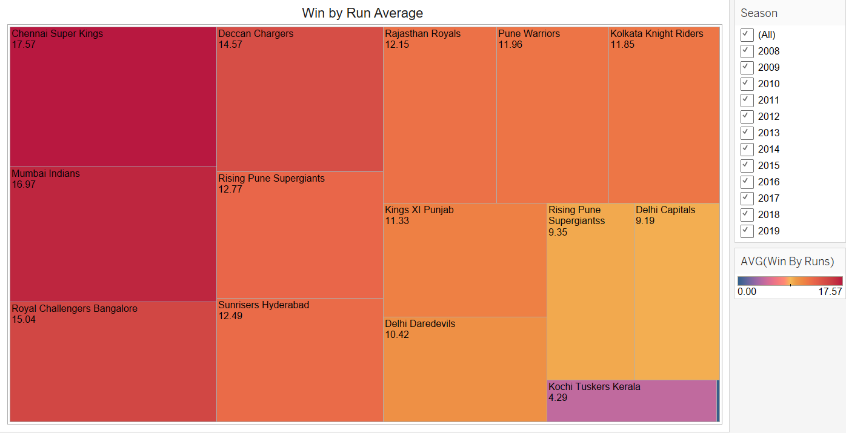

### Worksheet 5:

* It shows the list of top 20 players who have scored the most number of runs in entire IPL seasons. Virat Kohli was the only player who represented a single team from the start of IPL inaugural season and was leading run getter with 5,434 runs.

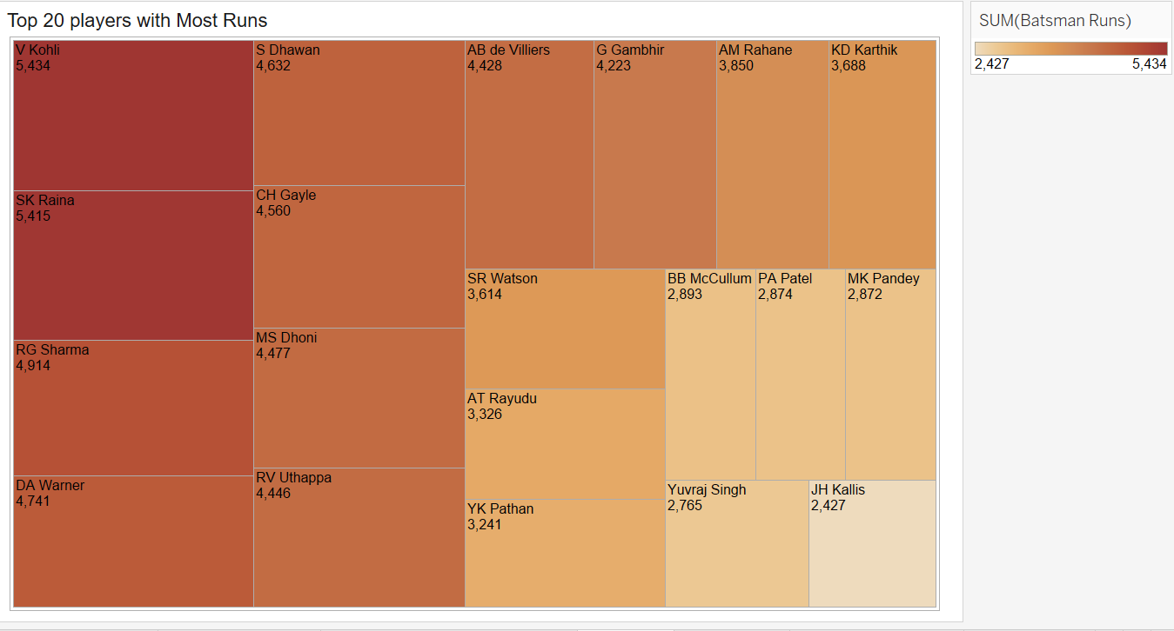

### Worksheet 6:

* It shows the top 20 players with the most number of wickets in IPL seasons. Zaheer Khan was the player who took the highest number of wickets in overall seasons, with 117 wickets in total.

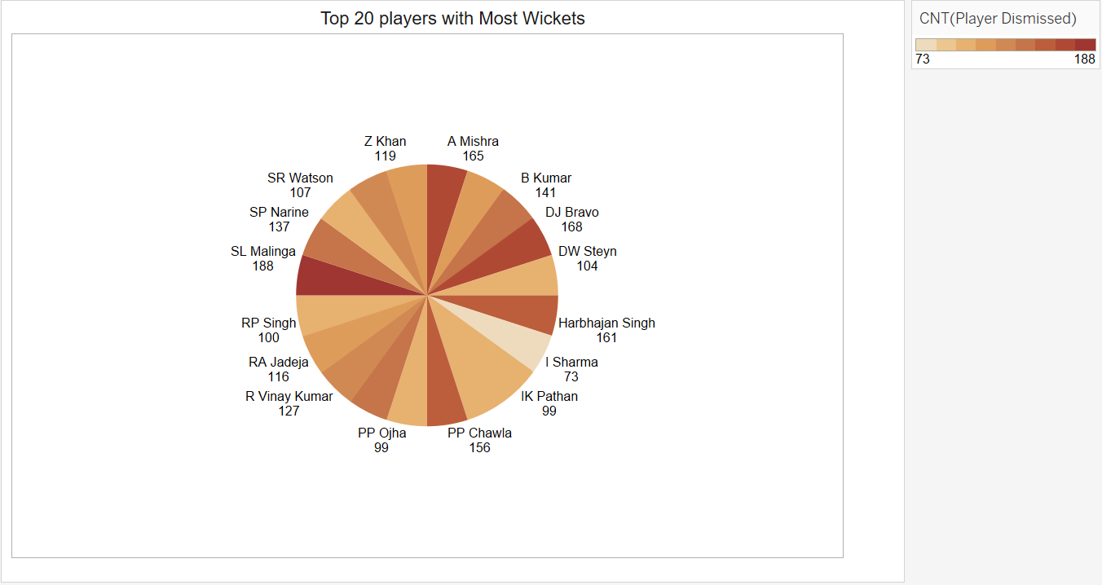

### Worksheet 7:

* This shows the players who won the most Man of the Match or MVp awards for their team on the winning side. AB de Villiers and Chris Gayle were seen leading the board for the same team Royal Challengers Bangalore, followed by MS Dhoni representing his team Chennai Super Kings.

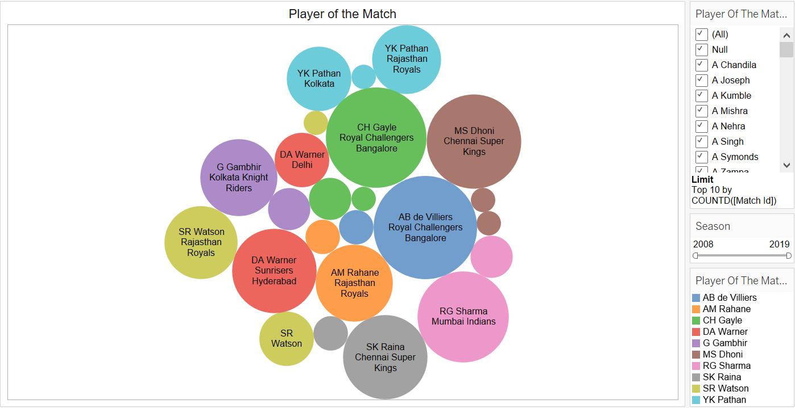

### Worksheet 8:

* It shows the Venues where the most number of runs were scored in each seasons, where mumbai, bengaluru and kolkata were the stadiums with high scoring rates.

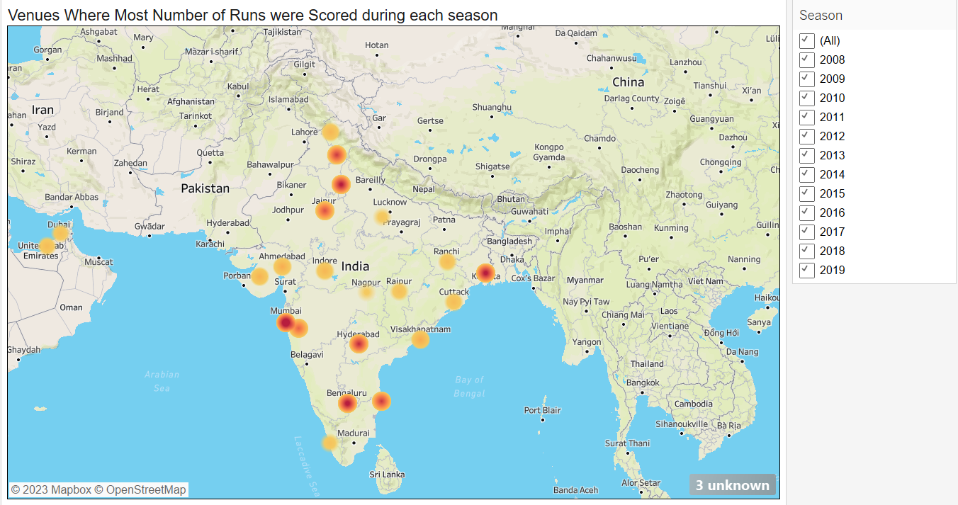

### Worksheet 9:

* It shows the teams winning percentage based on their toss decisions, where Mumbai Indians followed by Chennai Super Kings was seen having the best conversion rate, of winning toss and match too.

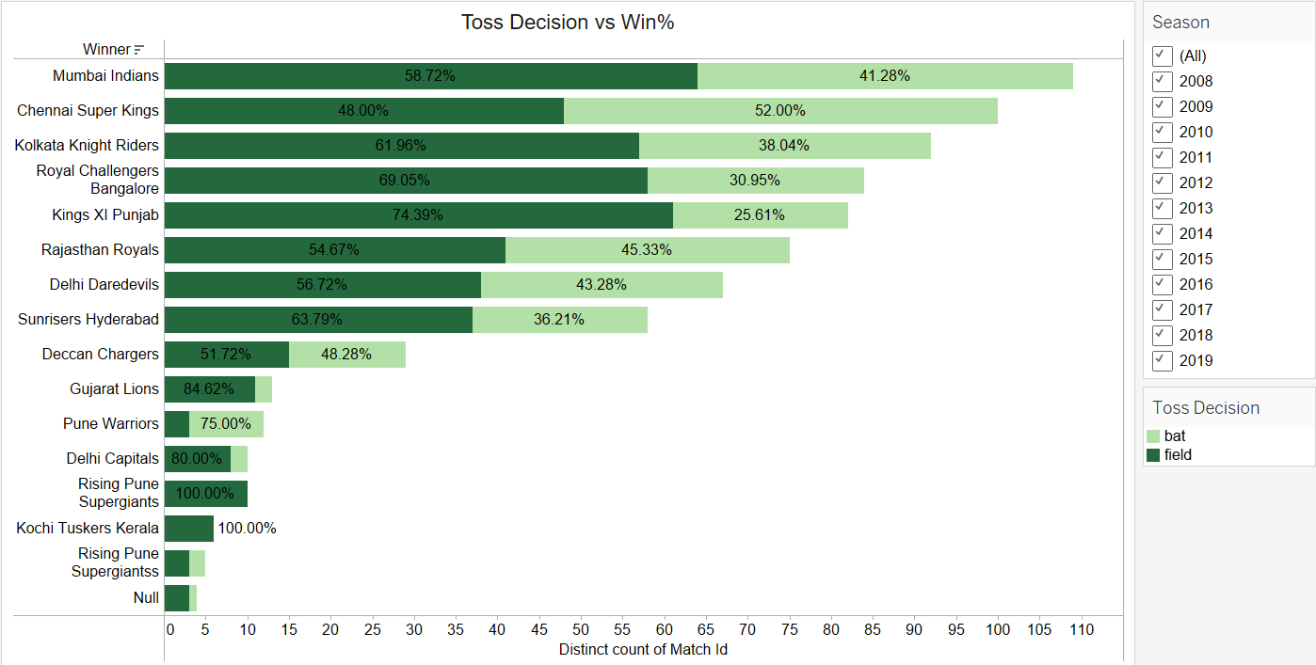

### Worksheet 10:

* This shows the stadiums which had the highest conversion ratio of toss to win, where Eden Gardens stadium of Kolkata was leading followed by Wankhede stadium of Mumbai.

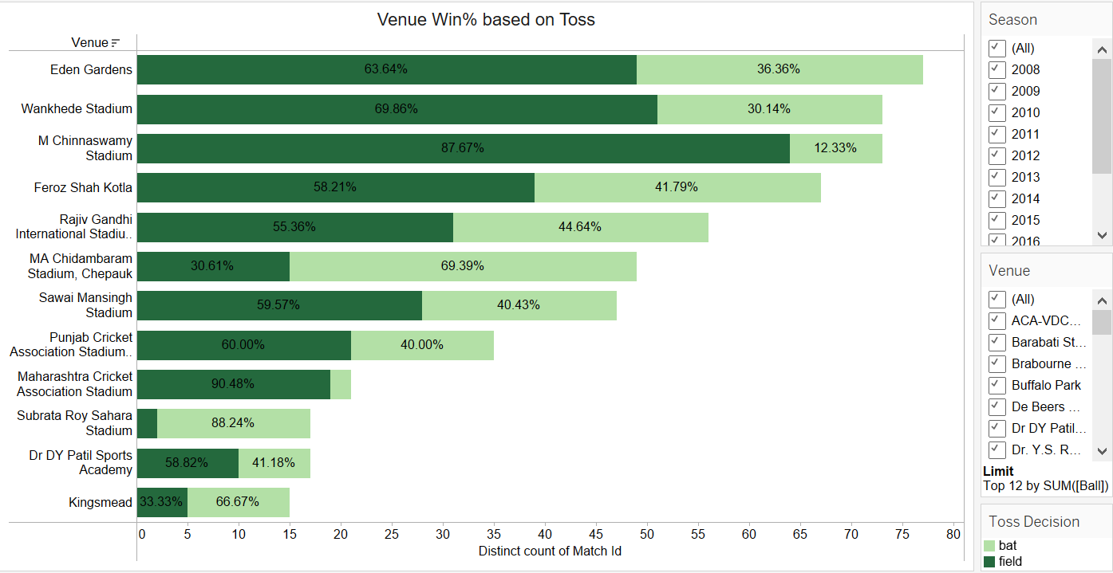

### Worksheet 11:

* It shows the graph of teams over forecasting Impact of Toss over teams win percentage.

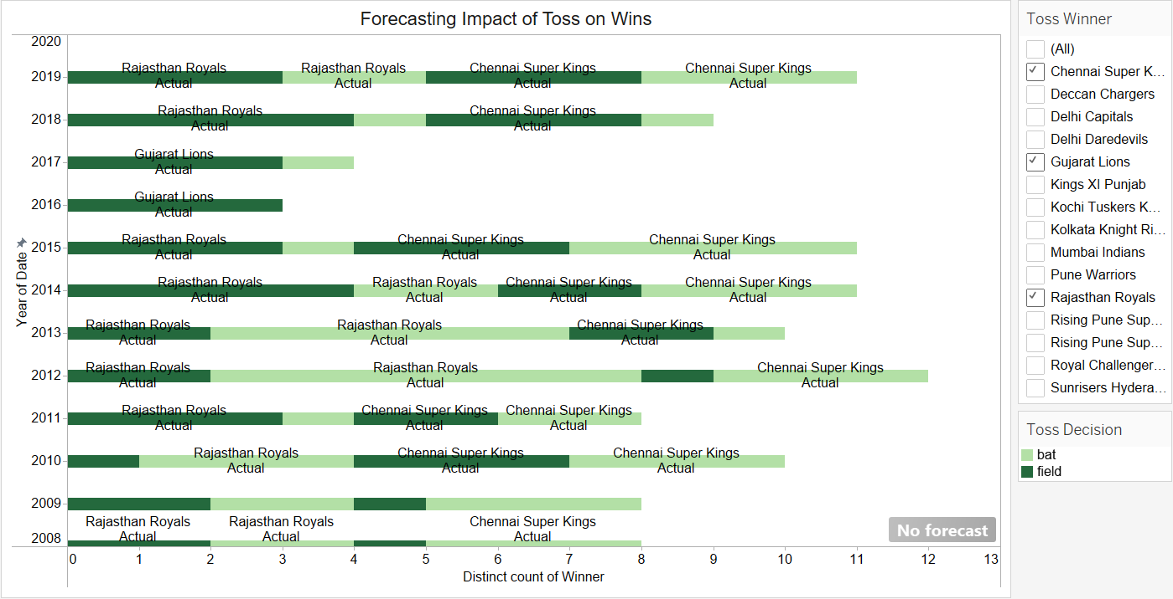

**n) Worksheet 12:**

* This shows the teams which scored the highest number of runs over no- ball, where Royal Challengers Bangalore was the team which scored highest runs over no-balls.

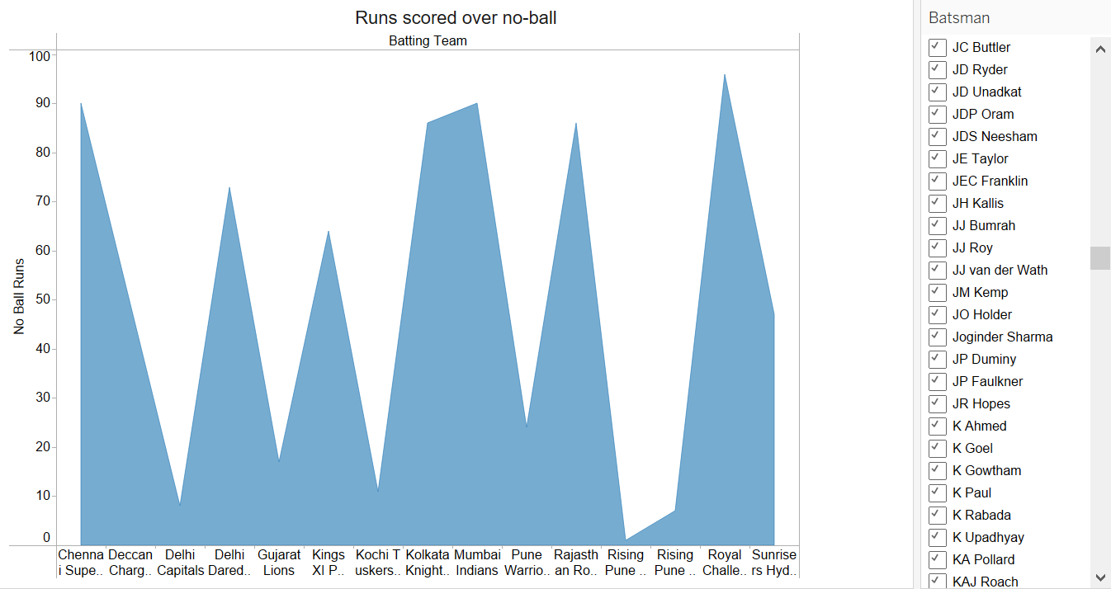

## Dashboards

### Dashboard 1:

* The below Dashboard shows the player from the particular franchise with the most number of runs and wickets for their team. It also has the player with the most number of MVP’s in overall IPL seasons.

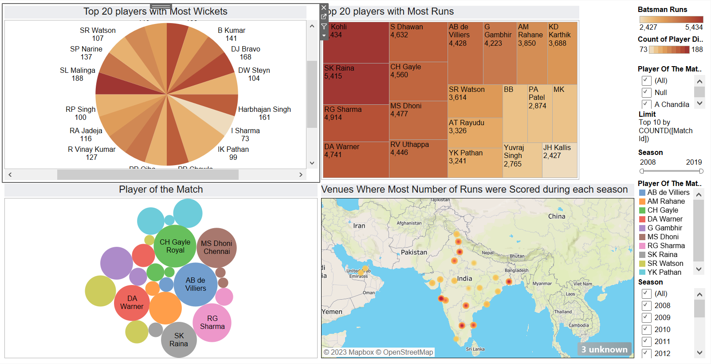

### Dashboard 2:

* The below Dashboard shows the charts of all franchise teams with the most number of wins in each season and their overall win percentage both by runs as well as wicket.

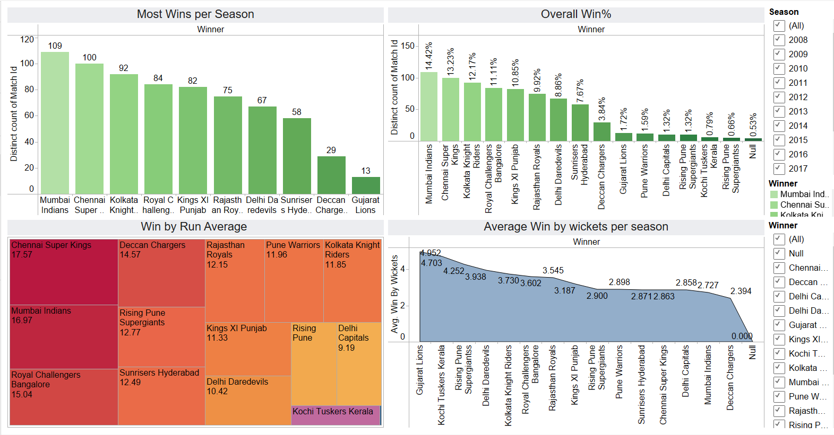

### Dashboard 3:

* The below Dashboard shows the result of the match on the basis of Toss over the weather forecast, match wins and wins at particular stadium after winning toss and electing to bat or field.

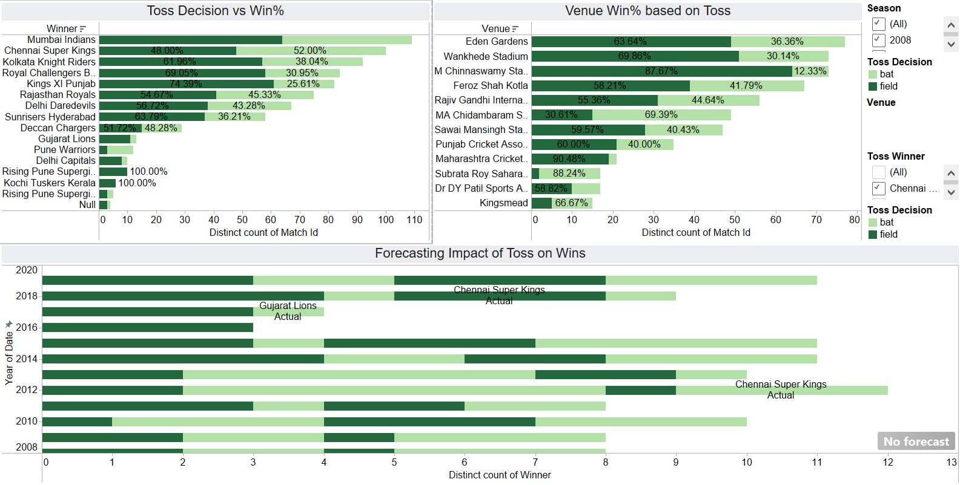

### 

## 

# USE CASES

* IPL Mega Auction
* IPL Team Selection
* IPL Analysis
* IPL Analysis for Fans

# CONCLUSION

The Indian Premier League (IPL) has given us important insights into the vibrant Indian cricket scene. We have used a variety of data visualization approaches for this project in order to identify trends, patterns, and KPIs within the league. In addition to improving our comprehension of the game, the visual depiction of player research, team structure, and match results has provided an engaging account of the IPL's development throughout time. I was able to pinpoint exceptional individuals, tactical team choices, and the influence of many elements on match outcomes by examining the wealth of data that is available. The report's visualizations offer valuable resources for cricket fans, commentators, and team managers alike, enabling a more profound understanding of the intricacies of the game. The knowledge acquired from this study can help with performance optimization, well-informed decision-making, and an enhanced fan experience as the Indian Premier League (IPL) persists as a major sporting event and cultural phenomenon in India. This effort demonstrates the value of data presentation in revealing the nuances of a major athletic event and highlights the need for more research in this fascinating area.

# FUTURE GOALS

Deploy machine learning strategies to predict key information, player performances, and match outcomes. It is advised to develop constantly updated live dashboards that provide viewers with up-to-date details on player statistics, team strategies, and match dynamics. Create interactive portals that enable fans to discuss and look over IPL details. Examine the integration of IPL data visualizations into social media platforms. Extend the visualization's scope to investigate correlations between the performance metrics of the Indian Premier League and other cricket leagues or other sports.

# 

# REFERENCES

1. https://public.tableau.com/app/discover
2. https://www.kaggle.com/search?q=ipl+complete+dataset

# GITHUB

https://github.com/amanp109/IPL_Visualization